EXPERIMENT – 6

PAYROLL FORM :
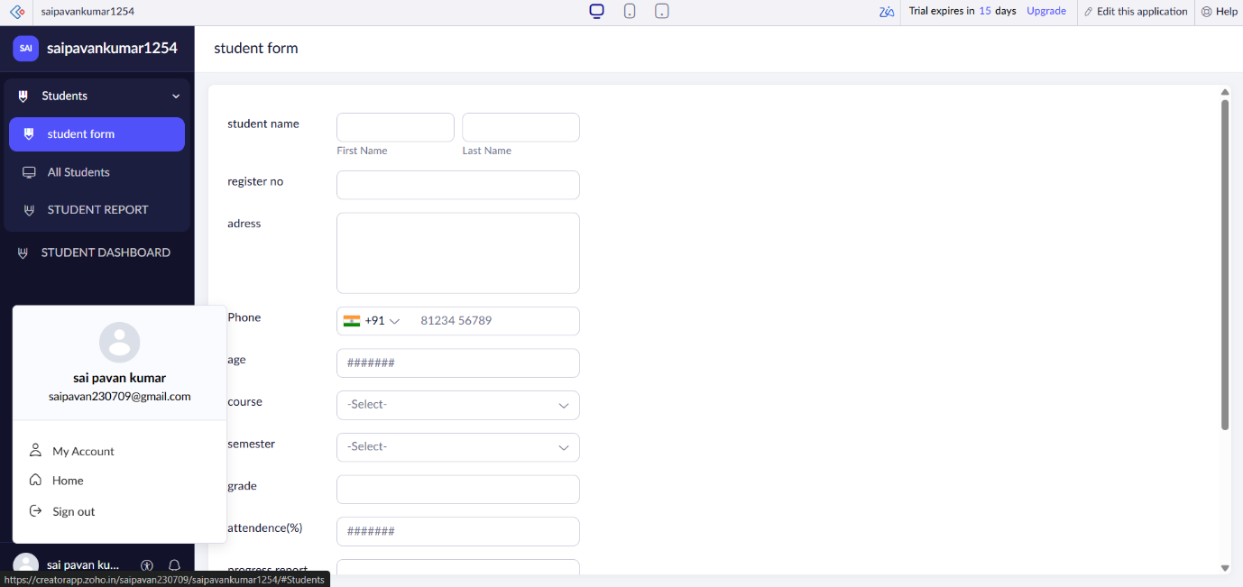

PAYROLL REPORT :
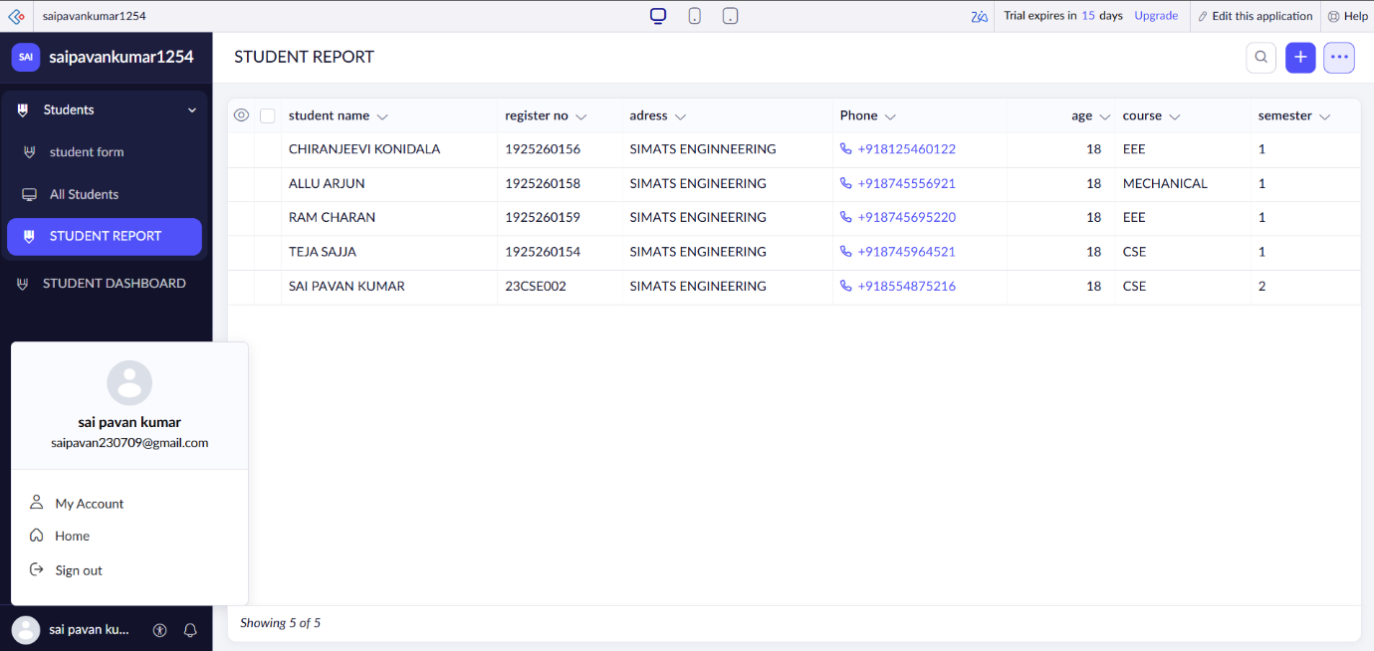

PAYROLL DASHBOARD :
